# **(Suggested topic area, e.g., T1) Title of presentation (14 pt, Arial)**

Presenting A. Author (student, if the presenting author is a student),1,2 B. Author,1 and C. Author2,* (12 pt, Arial)

1 *Department, University, City, Postal code, Country*

2 *Corporation or Laboratory, Street address, City, Postal code, Country* (*10.5 pt, Italic*)

*\*E-mail: author@somewhere.edu* (*10.5 pt, Italic*)

Main text (12 pt, Times New Roman) – one page only

Figure (if available)

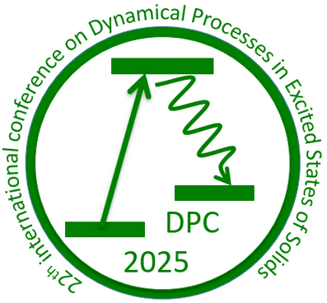

Figure caption (10.5 pt, Times New Roman)

## **References** (10.5 pt, Arial)

[1] A. Author, B. Author, C. Author. *J. Lumin.* **102**, 34–37 (2003).

[2] A. Author, B. Author, C. Author, et al. *J. Lumin.* **122**, 25–27 (2007).